Dear School Nurse or Health Care Provider:

My child is using a new diabetes management tool called Loop. We are excited to bring this tool to school because we believe it will allow for fewer blood glucose-related interruptions in our child's school day. While we have become accustomed to the new tool, we understand this may be unfamiliar to you. This sheet will hopefully help answer some questions about Loop.

Loop is an app on my child's iPhone. The app's icon is a green circle on a grey background. Similar to my child's Dexcom app, this app runs continuously in the background of the iPhone. Along with the Loop app, my child will be carrying a small plastic case with some hardware inside. It is called a RileyLink. The RileyLink is the device that allows my child's iPhone to speak directly with the insulin pump/pod.

Loop predicts my child's blood sugar for the next 6 hours and makes adjustments to the rate of insulin delivery to help keep blood glucose in the safe range we have set, in coordination with our doctor's input. Blood glucose trending high? Loop will add some insulin. Blood glucose predicted to go low? Loop will suspend some insulin.

In order to make those blood glucose predictions, Loop needs a few things:

* Current Dexcom (CGM) data (Loop gets this automatically so long as Dexcom is working)
* Meals (carbs) are entered into the Loop app (not on the pump/PDM)
* Boluses and corrections (if needed) are to be per the Loop's recommendation, unless specifically approved differently by myself or an authorized adult.
* RileyLink is carried by my child (not removed to another storage area)

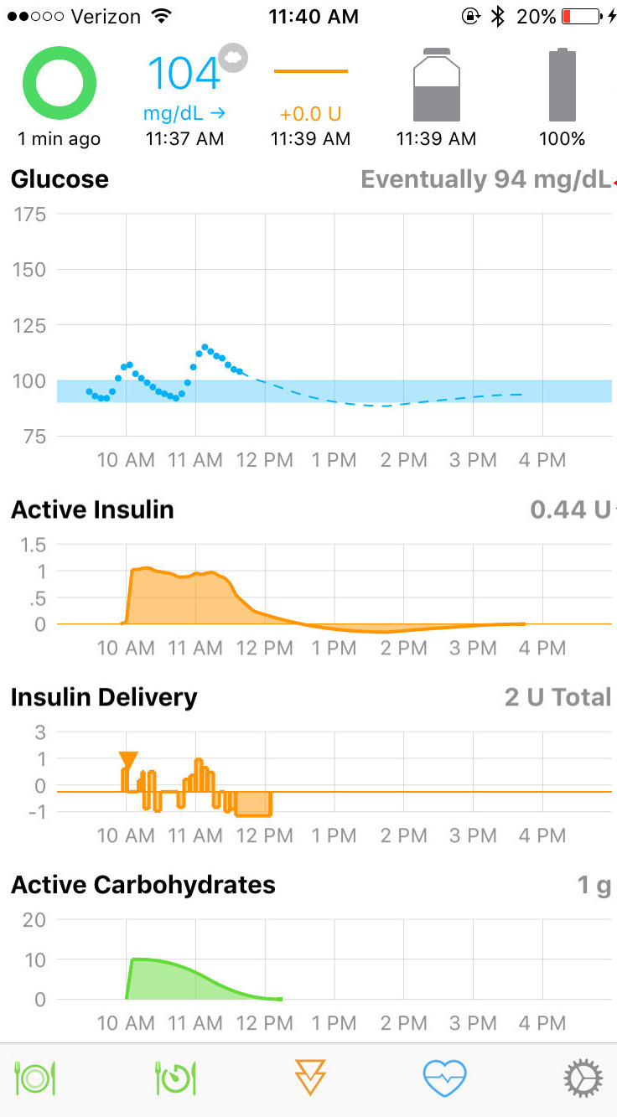

The main Loop display has information about Loop's data. Normally, the icon in the upper left will be a green circle. If the circle turns to red, please check if the Dexcom app is still receiving current data. If it isn't, please do the normal troubleshooting steps for my child's Dexcom app. Although there isn't too much to do for Dexcom issues and waiting it out is usually the only option.

If however, the Dexcom data is current (in other words the blood glucose data is less than 5 minutes old) and there's a red circle, please do the following steps:

* Turn the iPhone's Bluetooth off and then on again in the iPhone's settings.
* Restart the Loop app. If the iPhone has a home button, double tapping the home button and up-swipe on the Loop app window to close Loop app. If the iPhone doesn't have a home button, drag your finger from the bottom of the screen to halfway up and then let go to show the app picker. Up-swipe the Loop app window and tap on the bottom of the screen to close the app picker. Now open Loop app fresh.
* Use a paperclip (or similar) to gently turn the RileyLink's power switch off and then on again. Please be careful, the switch is a little delicate. "On" position is the switch being closest to the key ring at the top of the case. A green light should be seen faintly inside the case when RileyLink is turned on.

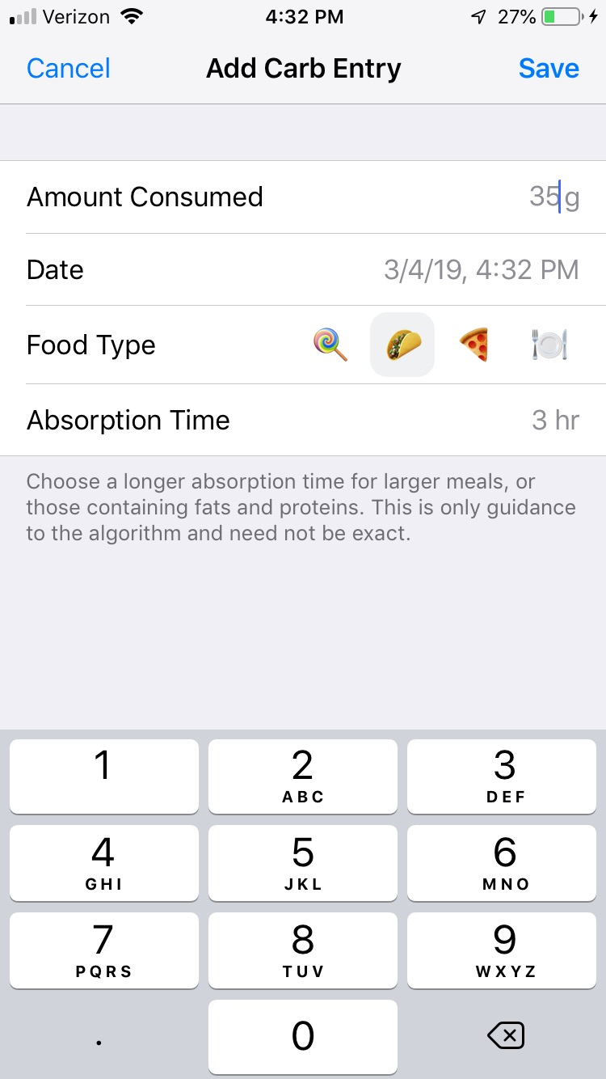**MEAL BOLUSING**

There are a few changes with how meals are bolused using Loop:

* 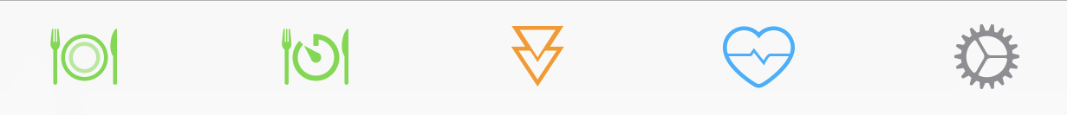No longer will you be using the PDM or pump itself for meal entries. Instead everything is done on the Loop app. To start bolus for a meal, please enter the carbs to be eaten by clicking on the green plate icon in the bottom, far-left corner of the Loop app screen.
* Along with carb counts, we will now also be including a "food type" icon to be used with the meal. For example, lunch might say "35g, taco" now for the sandwich and carrot sticks. Simply click on the icon for taco and enter 35g for the "amount consumed" line. After the carbs and food type are entered, press the save button in the upper right corner. (Important, see next page if you decide you need to edit/delete this entry after pressing the save button.)

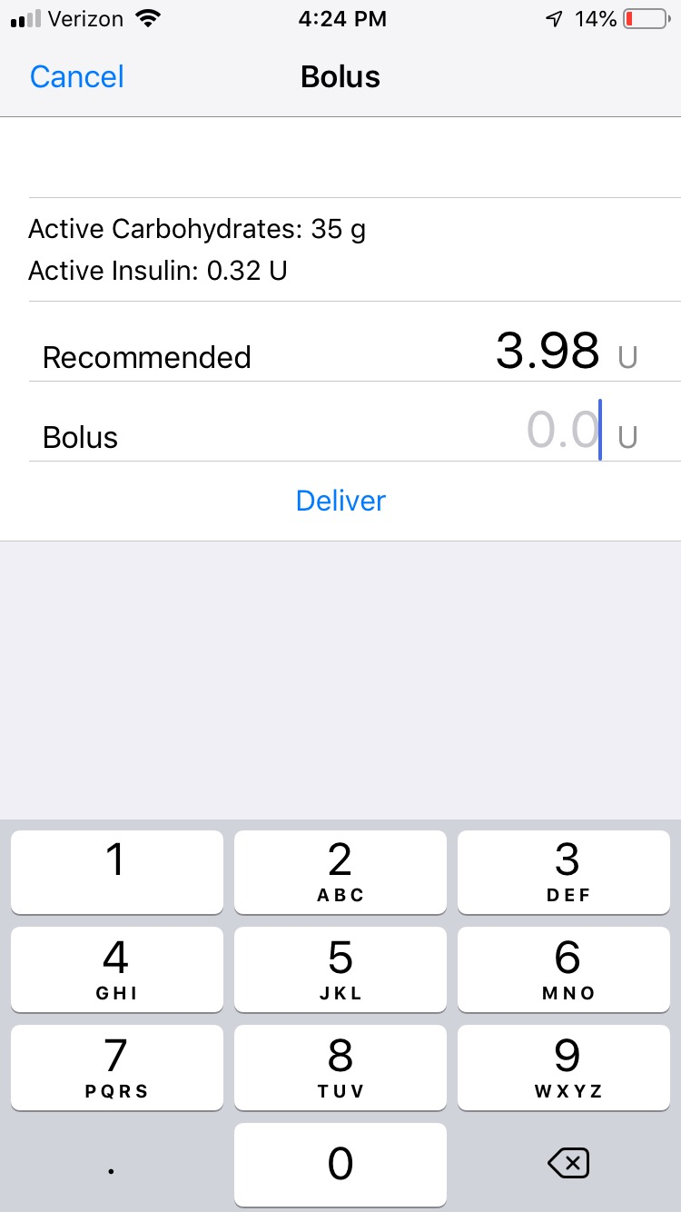

* Loop will then provide a bolus recommendation. Click on the recommended value itself (the "3.98 U" in this example), and the delivery line itself will be automatically filled out to match. Click the "Deliver" button to start the bolus. If FaceID or TouchID is required on the iPhone, my child may have to be holding the phone to actually press the "Deliver" button after you've confirmed the bolus amount is correct.

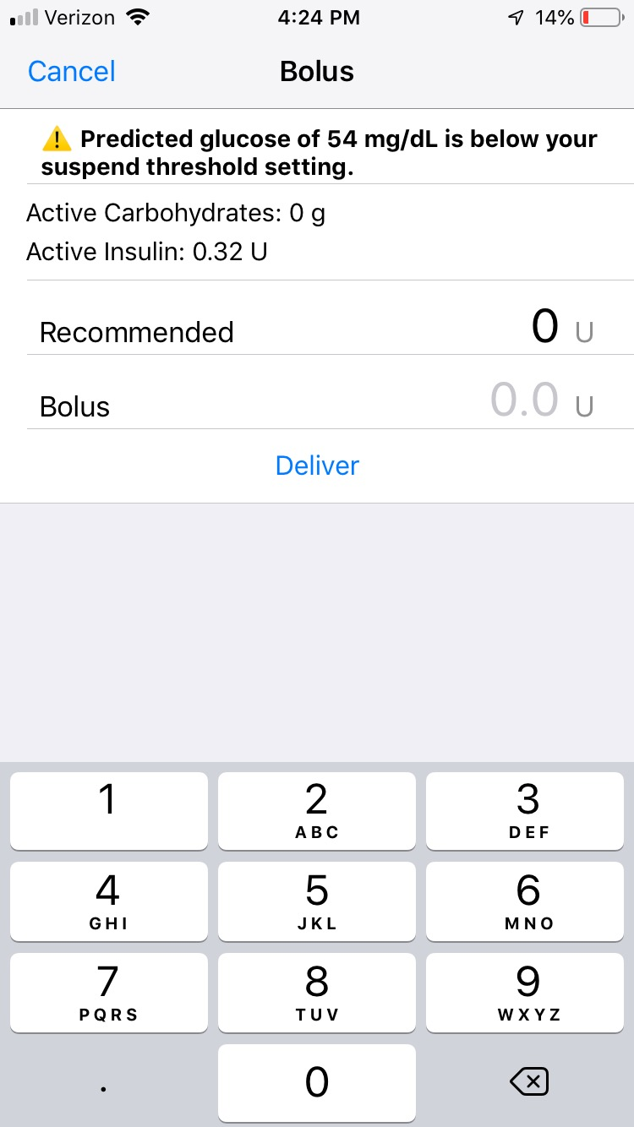

* In the event that my child's blood glucose is low or predicted to be low, Loop will not automatically provide a bolus recommendation and instead you will see a screen like the shown. A message will appear telling you there is no recommended bolus because "Predicted glucose of XX is below your suspend threshold setting". If this happens, please allow my child to eat, but call him/her back in 15-25 minutes to give the missing bolus as blood glucose will probably have risen enough by then to have a bolus recommendation waiting. Simply click on the bolus tool (the orange triangles icon at the bottom of the Loop app) and deliver the recommended bolus.

HOW TO EDIT OR DELETE A MEAL ENTRY

If you make a mistake in a meal entry, please make sure that you edit or delete the original entry ***before*** bolusing for the meal or adding a new carb entry. This is a pretty simple three-step process:

1. Cancel the bolus recommendation screen using the "Cancel" button in upper left corner.
2. Tap the green Active Carbohydrates graph on Loop's main screen to see saved meal entries.
3. Either tap the errant entry (if you want to edit it), or swipe left on the errant entry to bring up a delete button.

